**Project : hospital and clinic crm mangement**

* ***Phase 7: Integration & External Access***

1. ***Named Credentials***

**Purpose :** Store an endpoint URL and authentication in one place for secure callouts.

1. Setup → Named Credentials → New Named Credential
2. Enter: Label & Name
3. URL of the external system.
4. Identity Type: Named Principal (one login for all users) or Per User.
5. Authentication Protocol: Password Authentication or OAuth 2.0.
6. Save and use in Apex callouts as callout—no hard-coded URLs.

* ***External Credentials***

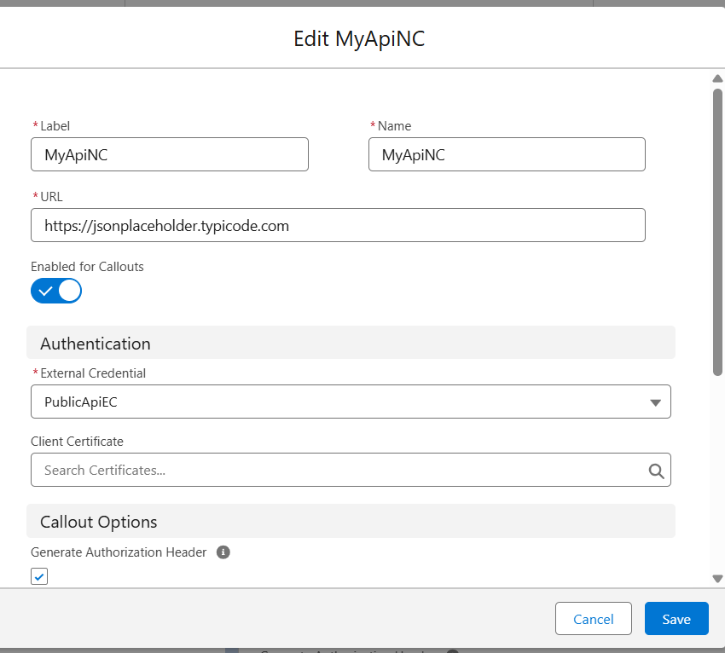

* ***Named Credentials***

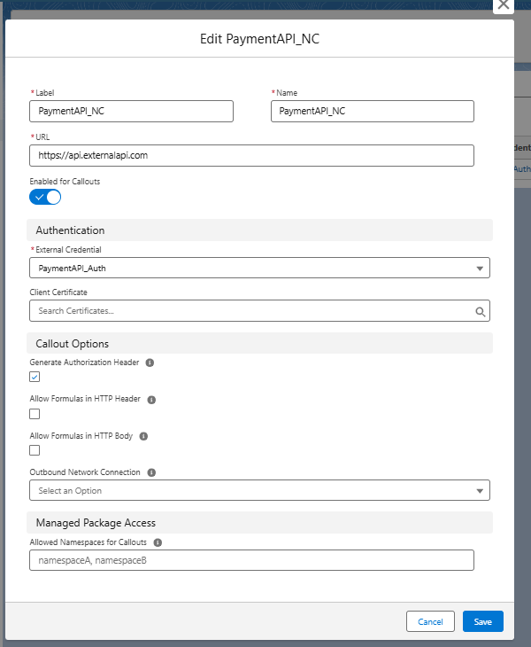

* ***Using Apex Class (Recommended for reuse)***

1. Go to Setup → Apex Classes → New
2. Enter a class name, e.g., PaymentAPIService
3. Paste the GET/POST code inside a method. Example:
4. Code :

public with sharing class PaymentAPIServiceAlt {

// GET Payment Details - returns response body

// Create HTTP request

HttpRequest req = new HttpRequest();

req.setEndpoint('callout:MyApiNC/api/appointments'); // Named Credential ka use

req.setMethod('GET');

// Create HTTP object and send request

Http http = new Http();

HttpResponse res = http.send(req);

// Check response

System.debug('Status Code: ' + res.getStatusCode());

System.debug('Response Body: ' + res.getBody());

// POST a Payment - returns response body

// Create HTTP request

HttpRequest req = new HttpRequest();

req.setEndpoint('callout:MyApiNC/api/appointments'); // Named Credential ka use

req.setMethod('POST');

req.setHeader('Content-Type', 'application/json');

// JSON body

String requestBody = '{"patientId":"P001","doctorId":"D001","status":"Scheduled"}';

req.setBody(requestBody);

// Send request

Http http = new Http();

HttpResponse res = http.send(req);

// Check response

System.debug('Status Code: ' + res.getStatusCode());

System.debug('Response Body: ' + res.getBody()); // JSON body safely formatted

// Optional: parse JSON response into a Map

* Open **Developer Console → Execute Anonymous**, then run:

***Code :***

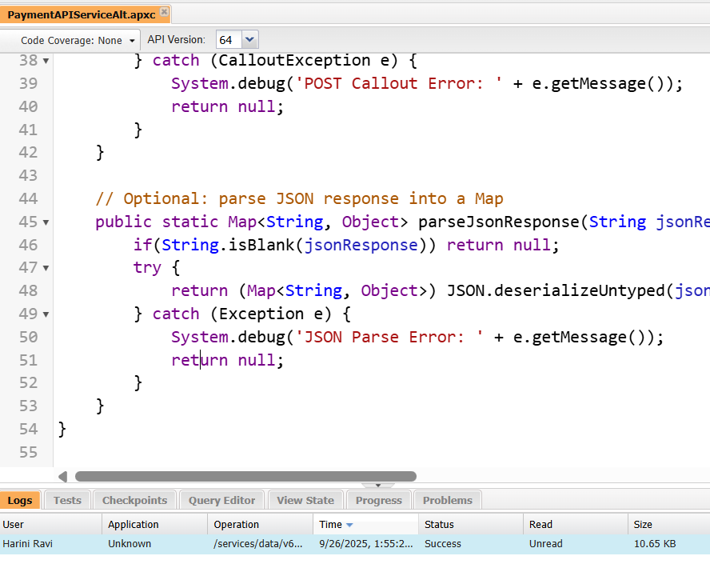

1. ***External Services***

**Purpose :** Declaratively connect Salesforce to REST APIs using Flows.

Steps:

1. Prepare a Swagger/OpenAPI spec of the external service.
2. Setup → External Services → New External Service
3. Fill in:

Name

Named Credential (from Step 1)

Swagger URL or file

1. Salesforce generates Apex actions for use in Flow Builder.
2. Usage: Drag actions into a Flow to call the external service without Apex code.
3. ***Web Services (REST/SOAP)***
4. Open Developer Console and Create Apex Class
5. Setup → Developer Console
6. File → New → Apex Class
7. Name it PaymentStatusAPI (or any valid name).

**Code :**

@RestResource(urlMapping='/Appointments/*')

global with sharing class AppointmentAPI {

@HttpGet

global static List<Appointment__c> getAppointments() {

return [SELECT Id, Name FROM Appointment__c LIMIT 5];

}

Appointment_Event__e evt = new Appointment_Event__e(PatientId__c='P1');

EventBus.publish(evt);